Copyright for test papers and marking guides remains with *West Australian Test Papers.*

They may only be reproduced within the purchasing school according to the advertised Conditions of Sale.

Test papers should be withdrawn after use and stored securely in the school until Friday 4th December 2009.

## PHYSICS

## YEAR 11

## 2B

**2009**

Electrical Fundamentals and Heating and Cooling

### INSTRUCTIONS TO CANDIDATES

**TIME**: 3 Hour Paper: **MARKS: 200**

Attempt **ALL** questions

**TIME**: 2.5 Hour Paper: **MARKS: 170**

**Omit balanced selection of questions to value of 30 marks**

**STRUCTURE OF THE PAPER**

|  |  |  |  |  |
| --- | --- | --- | --- | --- |
| Section | No. of  Questions | No. of questions  to be attempted | No. of marks  out of 200 | Proportion of  exam total |
| A: Short Answers | 15 | ALL | 70 | 35 |
| B: Problem Solving | 8 | ALL | 100 | 50 |
| C: Comprehension and  Interpretation | 2 | ALL | 30 | 15 |

Note: Above refers to 3 hour paper.

For 2.5 hour paper see statement on previous page.

**INSTRUCTIONS TO CANDIDATES**

Write your answers in the spaces provided beneath each question. The value of each question (out of 200) is shown following each question.

The enclosed Physics: Formulae and Constants Sheet may be removed from the booklet and used as required.

Calculators satisfying conditions set by the Curriculum Council may be used to evaluate numerical answers. The calculator **cannot** be a “**graphics”** calculator.

Answers to questions involving calculations should be evaluated and given in decimal form. Quote the final answer to not more than four significant figures. Despite an incorrect final result, credit may be obtained for method and working providing these are clearly and legibly set out.

Questions containing specific instructions to **show working** should be answered with a complete, logical, clear sequence of reasoning showing how the final answer was arrived at: correct answers which do not show working will not be awarded full marks.

Questions containing the instruction "**Estimate**" may give insufficient numerical data for their solution. Students should provide appropriate figures to enable an approximate solution to be obtained.

**Section A: Short Answers**

Marks allocated: 70 marks out of a total of 200 (35%)

Attempt ALL questions in this section. Not all questions attract the same marks.

Answers are to be written in the space below or next to each question.

1. Below is a picture of an Esky, a familiar item used in summer.

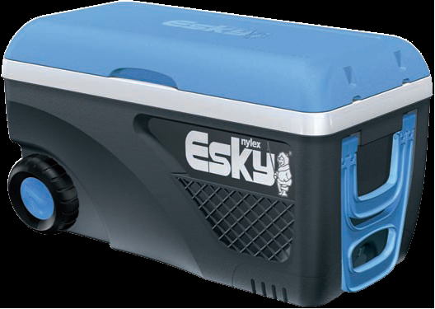

(a) A warm bottle of drink is placed in the esky that contains plenty of ice. List the

physics principles involved in its design and the process whereby the warm drink

becomes cooler by being placed in the Esky for a while. (3 marks)

(b) Why does some ice remain frozen even after many hours? (1 mark)

In the following multiple choice questions select the **best** answer and in the space provided give your explanation displaying your physics understanding.

2. When electric current flows through a tungsten filament as in an incandescent globe the filament becomes white hot. Compared to the current in the filament the current in the connecting wires is;

(a) less.

(b) more.

(c) the same. (2 marks)

(d) need more information.

Reason for my choice: (2 marks)

3. The diagram below represents a network of resistors.

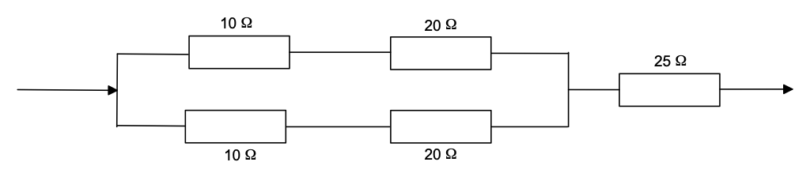

(a) What is the total resistance of this network? (3 marks)

(b) Which resistor will carry the largest current? (1 mark)

4. Solar water heaters are popular in Perth.

(a) In Perth which direction does the main panel face and for what reason? (2 marks)

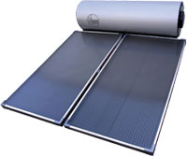

(b) The intensity of the sun is approximately 800 W m-2 and a typical heater would have an area of about 2 m2. If the water was not circulating calculate the temperature increase in 30 min if the mass of water in the pipes in the panel is 15 kg. (3 marks)

5. A student wishes to cool his 250 g soft drink (specific heat 3500 J kg K-1) from an initial temperature of 30 0C to a more pleasant 5 0C.

(a) What mass of ice should he add? (4 marks)

(b) How could he make the cooling occur more quickly? (1 mark)

6. Calculate the electrical energy required to:

(a) change the temperature of 500 g water in an insulated kettle from 25 oC to 100 oC.

(2 marks)

(b) calculate the extra energy to boil half of this mass into steam. (2 marks)

(c) If the kettle is connected to the mains (240 V) how long will the kettle be on for to provide 10 000 J? The heating coil has a resistance of 50 Ω. (3 marks)

7. In a car the starter motor is connected to work off the 12 V DC car battery. The lights also are connected to the same battery but have very much thinner wires. Explain the reason for this difference. (3 marks)

8. Peter uses a map-reading light which operates from his 12 V car battery to read a street directory.

(a) How much energy would be converted to heat and light by the bulb if a current of 2.0 A

flows through the bulb for a time of ten minutes? (2 marks)

b) How much charge flows through the bulb in this time? (2 marks)

9. Aaron, a keen surfer, decided to test the insulating properties of two different wet suit materials. Hot water was poured into each of the test tubes A and B and he wrapped an equal thickness of the two different wet suit materials around each test tube (not shown in diagram).

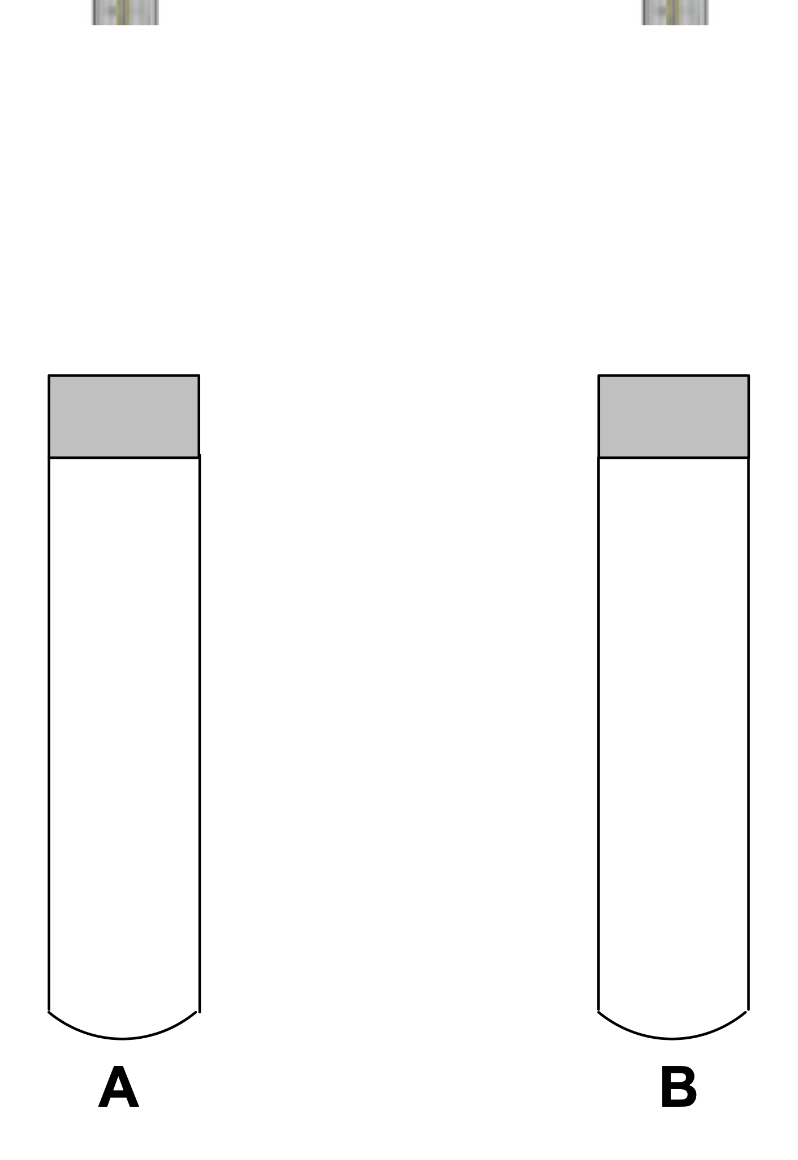

(a) List two variables he should control to ensure the investigation is meaningful. (2 marks)

(b) What variables should Aaron measure for him to make a valid conclusion? (2 marks)

(c) What results would he obtain in order to make a conclusion as to which material was

the better insulator? (1 mark)

10. Thomas heated three solids A, B and C until they melted. As they cooled he recorded the temperature of each at regular intervals. He then plotted the cooling curves for each. A copy of the graph is shown below. The final temperature was about 20 0C by which time all three were solid. Equal masses of solids A, B and C were used.

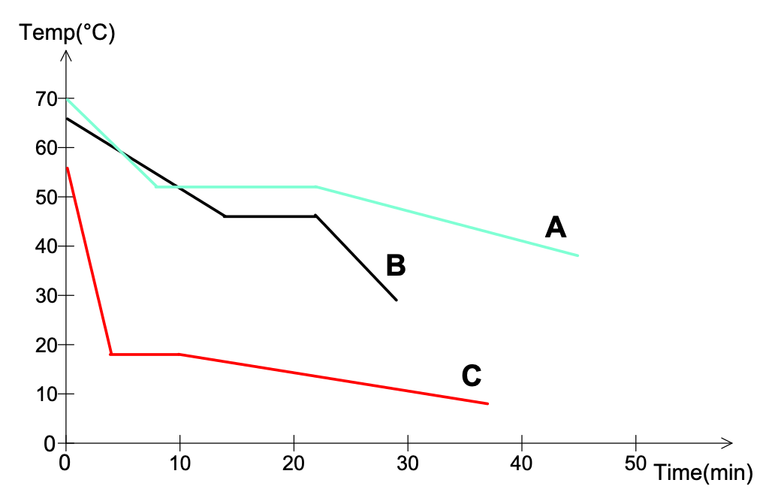

(a) Why did Thomas decide to have identical masses for samples A, B and C? (2 marks)

(b) Which solid has the highest melting point? What is the approximate numerical value of this temperature? (2 marks)

(c) Which solid has the largest specific heat capacity? Give a reason for your choice.

(2 marks)

(d) Which solid has the largest value for its Latent Heat of Fusion? Give a reason. (2 marks)

11. An innovative design feature is to fill the gap in double brick walls with a substance that changes phase at a suitable temperature. Which substance from the previous question would be suitable in Perth in summer and explain the physics principles for using this design feature. (4 marks)

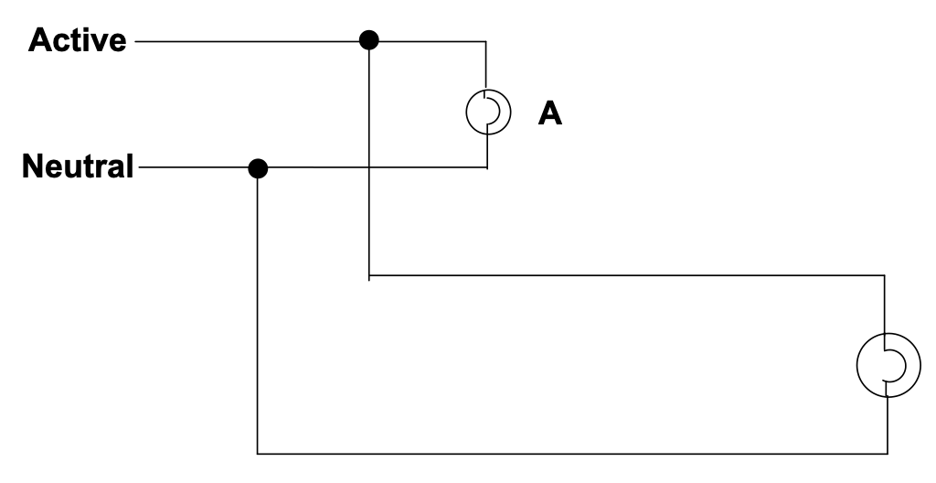12. The display manager in a department store intends to use two identical floodlights. Each floodlight is marked “240 V, 1200 W”. One floodlight is connected via a short lead to a power point and the other, which is going to provide back lighting is connected via a very long extension lead to the same power point.

(a) Circle the electrical arrangement that is illustrated in this diagram. (1 mark)

The lights are connected in:

Series Parallel

(b) The display manager wonders why the floodlight on the extension lead is slightly

dimmer than the one on the shorter lead and asks you for help to explain the difference.

What is the reason for this difference? (2 marks)

(c) Calculate the current flowing in globe A, assume the connecting wires for A are so short

that their resistance is negligible. (2 marks)

13. Students at school often bring cooled water to class in plastic drinking bottles. Explain the physics principles involved by students when they:

(a) wrap a towel around the plastic bottle. (2 marks)

(b) sometimes soak that towel in water. (2 marks)

14. One small metal coated ball carries an electric charge of +5 nC. A second, identical ball carries a charge of – 10 nC. The balls are suspended 30 mm apart by insulating threads.

Draw the electric field around each sphere. (2 marks)

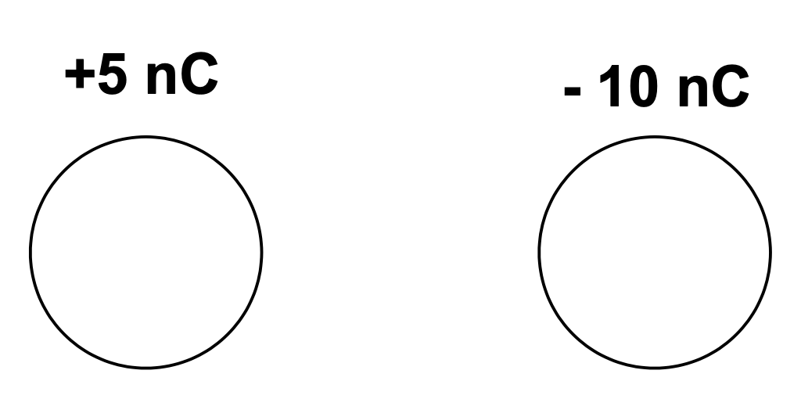

(b) There is an electrostatic force between the spheres. Indicate the direction of that force on the left by an arrow on the above diagram. (1 mark)

(c) The balls are allowed to touch and then separated. How will your answer to (b) change? Calculations are not required but you should indicate if the force has a change of magnitude and or direction. (2 marks)

15. Below is a diagram of the equipment needed to build a **thermostat** which will activate an alarm when the area is heated dangerously. The bimetallic strip consists of two identical strips of two different metals riveted together.

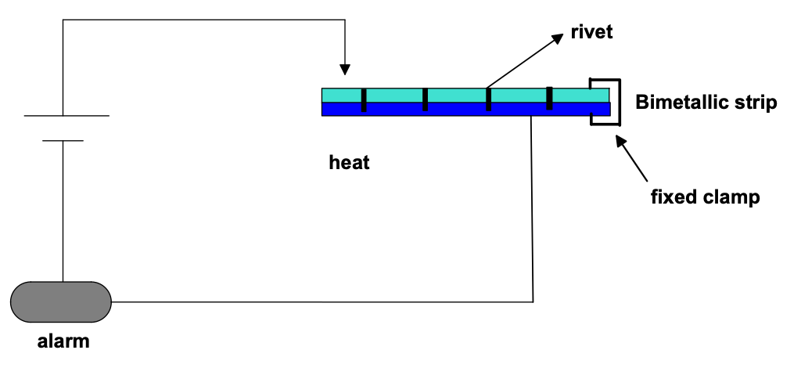

Explain the physics principles involved in this piece of equipment being able to activate the alarm in the case of fire. (3 marks)

**END OF SECTION A**

**Section B: Problem Solving**

Marks allotted: 100 marks out of a total of 200 (50%)

This section contains **8** questions.

Answer the questions in the spaces provided.

1. (13 marks)

Compact fluro globes are becoming more popular and soon you will not be able to purchase the incandescent globes we have used for ages. A student noticed in the shop one of these globes was advertised at a rating of 18 W but to have equal brightness to that of a 100 W conventional (incandescent) globe.

 

(a) What is the essential difference between these globes and why is the government phasing out the incandescent globe? (1 mark)

(b) If the new globe is assumed to be 100% efficient, what was the efficiency of the

incandescent globe? (1 mark)

Now, the student decides to conduct an investigation relating to the heat output from each type of globe. He makes a circuit with each globe in parallel as shown below. Each globe is placed in an insulated cubic container of dimensions 0.8 m x 0.8 m x 0.8 m.

(volume = 0.5m3) of containing air. The insulated cubes are identical and a thermometer is placed in each and the current flowed for 5 min. A small fan (not shown) ensures the air is circulated inside the insulated cubes. The fan, for this question, consumes negligible energy.

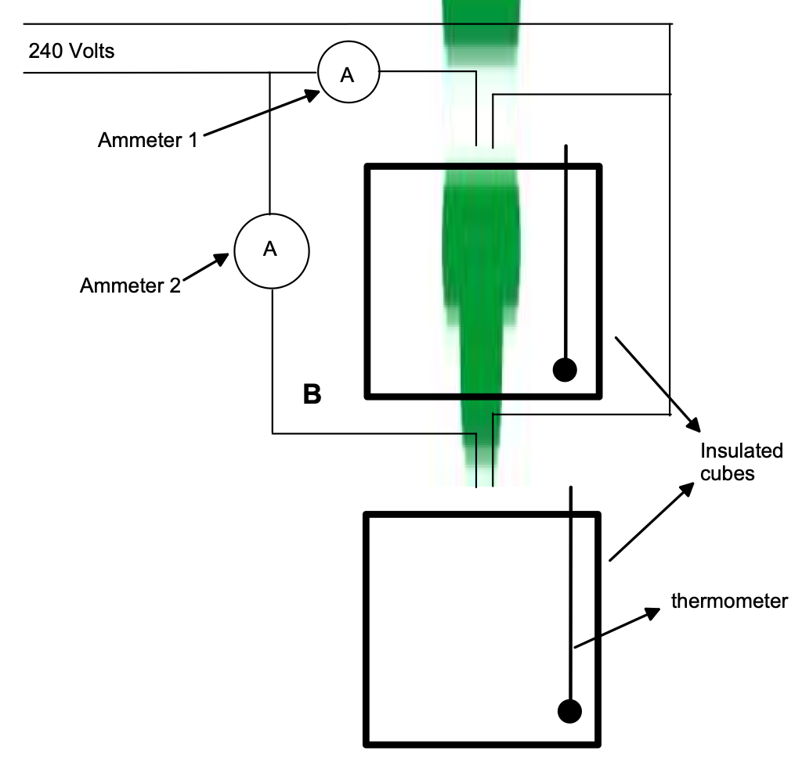

The following results were obtained,

Volume of air = 0.5 m3

Mass of each globe = 30 g

Initial temperature of air = 15 oC

Final temperature A = 40 o C

Final temperature B = 20 o C

Experimental time = 5 min

Density of air = 1.3 kg m – 3

Specific heat of glass = 650 J kg – 1 oC - 1

Data for this question is in the data sheet.

(c) Using the data recorded above, what conclusion would you reach from this experiment? (1 mark)

(d)Why were the globes connected in parallel? (1 mark)

(e) Calculate the heat output for both globe A and globe B in the 5 min experimental period.

(3 + 2 marks)

(f) Calculate the ammeter reading for both ammeters. (2 + 2 marks)

Ammeter 1__________

Ammeter 2__________

2. [13 marks]

An electrical circuit is set up by a teacher to test students understanding of current, resistance and potential difference (voltage). The meters used in the circuit do not have any influence on the circuit other than to register current and potential difference. The students could see the readings on five of the meters but the teacher had covered the dials of three of the meters so the students could not see what they registered. A diagram of the circuit is below.

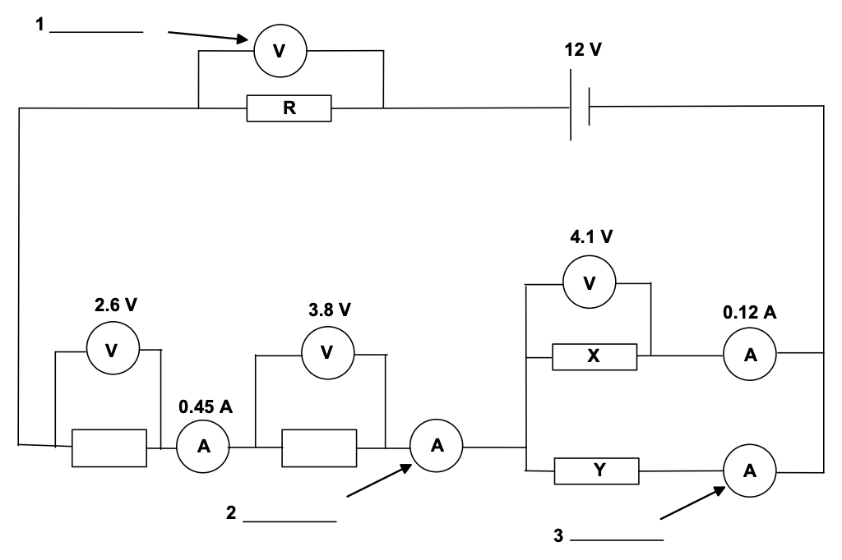

(a) Calculate what the readings on the three meters would be, and write the values next to the meters in the spaces provided. (3 marks)

(b) Calculate the resistance of X. (2 marks)

(c) Calculate the quantity of charge which flows through resistance Y in 5.0 min. (3 marks)

(d) Calculate the value of resistance R. (2 marks)

(e) The battery can supply1.4 MJ of energy. For how long could this battery operate?

(3 marks)

3. (13 marks)

In order to determine the specific heat of an unknown liquid students were encouraged to first find the heat generated by a Bunsen flame. Later, using that same flame, the students heated a known mass of the unknown liquid. A diagram of the apparatus is shown below.

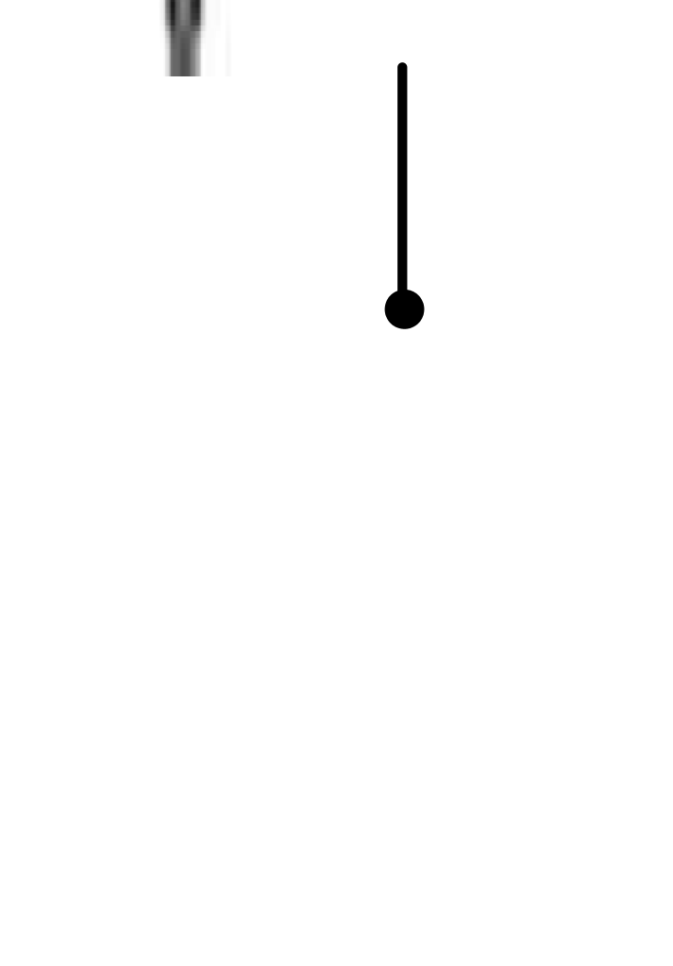

(a) List two good techniques the students should consider while heating the liquid. (2 marks)

Initially the water was heated and the temperature rise recorded

|  |  |
| --- | --- |
| Mass of water (kg) | 0.25 |
| Initial Temp of water (oC) | 20 |
| Final Temp of water (oC) | 55 |
| Change in temp of water (oC) |  |
| Time for which water was heated for (s) | 240 |

(b) Use the appropriate formula to find the heat generated by the Bunsen each second. (3 marks)

(c) Now before replacing the water with the unknown liquid the student was asked to list the main sources of error in the determination of the power of the bunsen flame.

List two likely errors. (2 marks)

The water has been replaced by liquid X and the results noted below.

(d) In order for the results to be accurate list two conditions that the students should have taken care to duplicate. (2 marks)

|  |  |
| --- | --- |
| Mass of liquid X (kg) | 0.35 |
| Initial Temp of liquid X (oC) | 25 |
| Final Temp of liquid X (oC) | 65 |
| Change in temp of liquid X (oC) |  |
| Time for which liquid X was heated (s) | 220 |

(e) Determine the specific heat of liquid X showing all your calculations. (4 marks)

4. (13 Marks)

In an experiment to determine the latent heat of ice a student used the familiar apparatus below.



Ice, that was previously dried with a tissue, was added to the water in the beaker which was

insulated until a significant temperature drop was recorded. The mass of the beaker was

then reweighed. The liquid was stirred continuously.

(a) Why was the beaker insulated and why was the mass of ice not measured by first weighing it and then adding to the insulated beaker? (2 marks)

(b) Why did the student dry the ice with a tissue before adding it to the water? (1 mark)

(c) If room temperature was 25 0C , why was starting the experiment at 40 0C and

concluding at approximately 10 0C a good experimental technique? (2 marks)

The student tabulated the following results:

|  |  |
| --- | --- |
| Mass of water before adding the ice (g) | 100 |
| Mass of water after adding ice (g) | 135 |
| Initial temperature (0C) | 40 |
| Final temperature after adding the ice (0C) | 10 |
| Mass of ice (g) |  |

(d) Using the students data calculate a value for the Latent Heat of ice. (6 marks)

(e) Determine the % error between your value and the accepted value of 3.3 x 105 J kg-1 and comment on the accuracy and techniques that the student used. (2 marks)

5. (11 marks)

An innovative way of finding the specific heat of an industrial liquid in motion is by using the apparatus below.

The continuous-flow calorimeter

This was first developed by Callender and Barnes in 1902 for the measurement of the specific heat capacity of a liquid, and is shown in the diagram below. Its main advantage is that the thermal capacity of the apparatus itself need not be known.

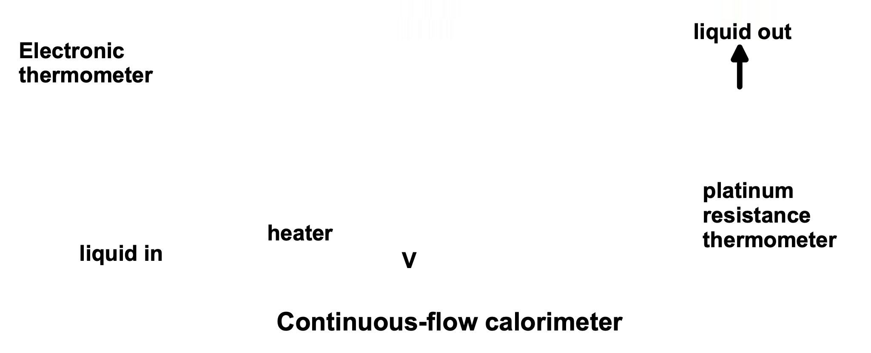

Liquid flows in from a constant-head apparatus at a constant rate past a thermometer (T1). It then flows around the heater coil and out past a second thermometer where the outlet temperature (T2) may be measured. When steady-state conditions have been reached (a temperature difference between inlet and outlet points of 10 oC is reasonable) the temperatures and the flow rate of the liquid (m) are measured. A vacuum jacket round the heater coil reduces heat losses.

Results for a typical experiment are shown in the table below:

|  |  |
| --- | --- |
| Mass of liquid flowing in 1 min (g) | 250 |
| Inlet temperature (oC) | 50 |
| Outlet temperature (oC) | 80 |
| Voltmeter reading (V) | 240 |
| Current reading (A) | 2.5 |

(a) What is the resistance of the heating coil and why is it surrounded by a vacuum tube?

(2 +1 marks)

(b) In continuous flow the temperature change remains constant as does the flow rate. Why then is the heat capacity of the apparatus (the glass / heating coils etc) not included in your calculations? (2 marks)

(c) Using the data in the data sheet calculate the specific heat capacity of the liquid.

(5 marks)

(d) This apparatus can be used to find the specific heats of liquids at a variety of

temperatures easily. What other substance could it be used for? (1 mark)

6. (11 marks)

A student decides to investigate some properties relating to the electrical resistance of a 100 cm

metal wire. The equipment chosen is illustrated below.

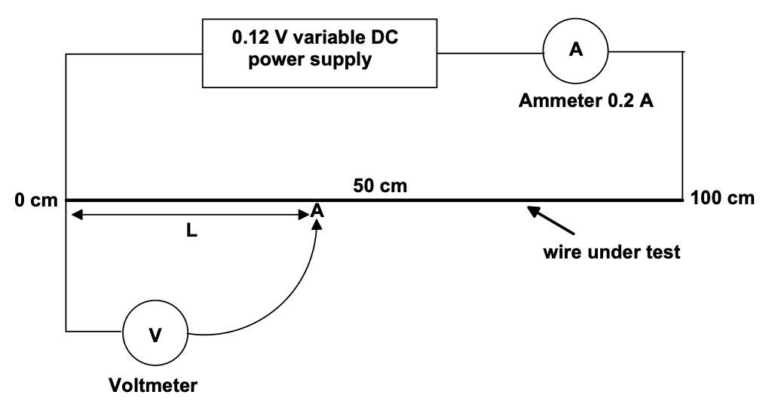

The point A is a crocodile clip that can be easily moved along the a wire under test and the length of wire chosen is measured as L [cm].

Results were obtained as shown below.

|  |  |  |
| --- | --- | --- |
| Length of wire  (cm) | Reading of Voltmeter  (V volts) | Resistance of selected length (L) of wire (ohms) |
| 15 | 2.05 |  |
| 35 | 4.0 |  |
| 50 | 6.6 |  |
| 60 | 8.1 |  |
| 80 | 10 |  |

(a) Knowing the ammeter reading was a constant 0.2 A, fill in the column labelled Resistance of selected length (L) of wire (ohms). (3 marks)

(b) Plot a graph on the grid below of Length of wire (L) on the x axis and Resistance of the wire on the y axis. Label it A. (3 marks)

(c) What conclusion can you draw from this plot? (1 marks)

(d) The wire is now replaced by a wire of the same material but of twice the thickness. No calculations are required but show on the same graph the results you would expect for this length of wire. Label this graph B. (2 marks)

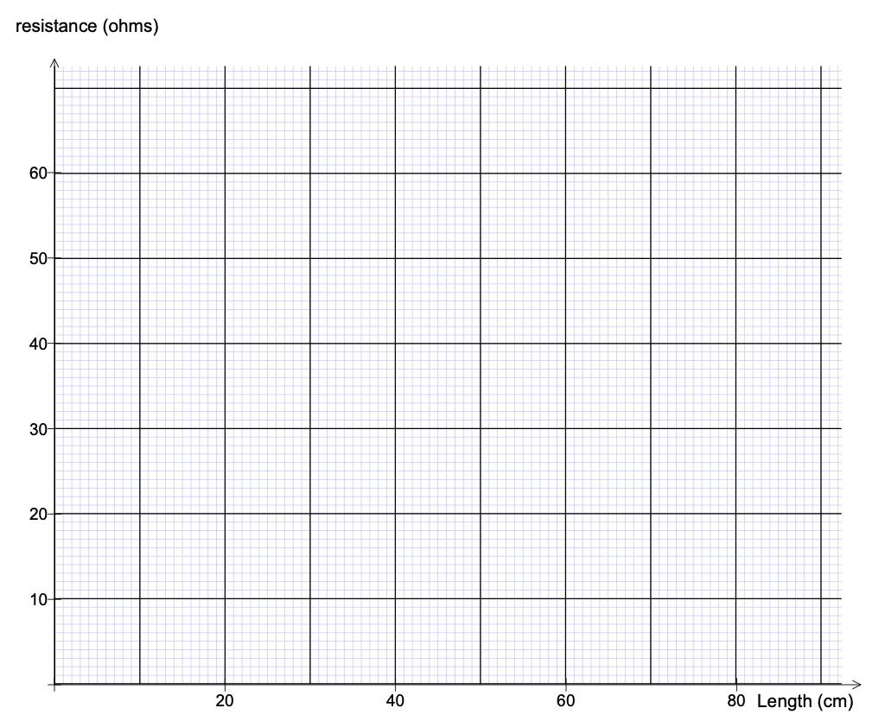 (e) Lastly the wire is replaced by a silver wire, an excellent conductor of electricity. It’s thickness is the same as in part (d). No calculations are required but show on the graph the results you would expect for this length of wire. Label this graph C. (2 marks)

7. (15 marks)

A student was completing a “black boxes” practical test. **Below are the instructions.**

**Aim:**

To determine the resistor network inside a numbered "black box".

All the boxes have 5 resistors they are: three x 100 ohms and two x 50 ohms. Each resistor is accurate to ± 1 ohm.

(a) What does this indicate about the error in the 50 ohm resistor? (1 mark)

**Hint**

If the network has parallel arms and in any arm there is more than 1 resistor then they are all of the same value **R1 =R2 ,**  **R3 =R4 =R5**

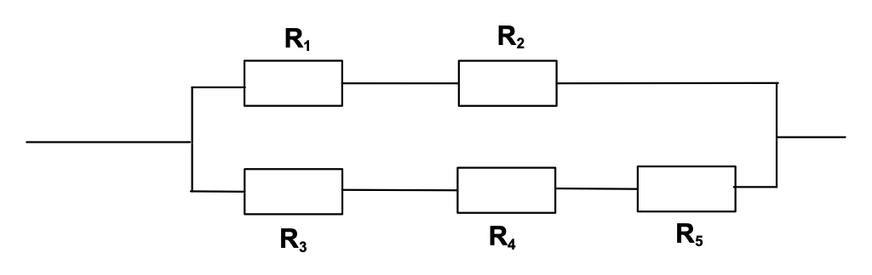

ie

The student inserted black box number 1 into the circuit below and measured the current to be

60 mA and the voltage of the battery was 10 Volts.

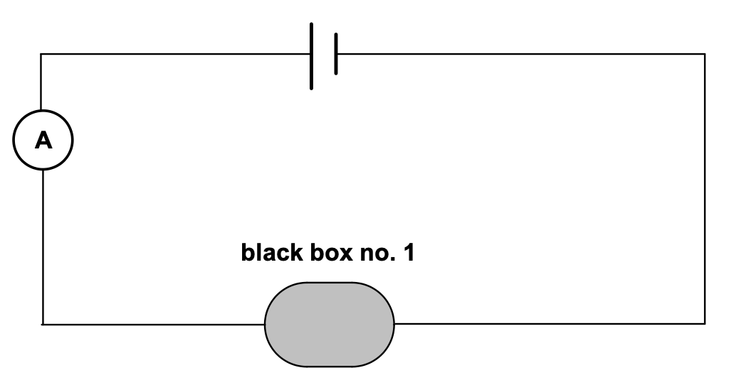

(b) Find the total resistance of black box number 1. (2 marks)

(c) Draw a circuit containing the 5 resistors that has this resistance and justify your answer by doing a calculation. (2+ 2 marks)

(d) When black box number 2 replaced black box number 1 in the circuit the current was

31 mA. Again find the resistance and draw a circuit containing the 5 resistors that has

this resistance and justify your answer with a calculation. (2+2+2 marks)

(e) Why should the student choose a battery voltage that would allow the current flowing through the black box to be reasonably small? (2 marks)

8. (11 marks)

A lump of ice at 0 oC and mass 25 g is added to a polystyrene cup containing 200 g of water at 20 oC. Thermal equilibrium is reached when the contents of the cup is 9 oC.

(a) What do you understand by the term “thermal equilibrium” and how would you know it had been reached? (2 marks)

(b) Calculate a value for the latent heat of fusion of ice assuming water has a specific heat value of 4180 J kg -1 K-1. (5 marks)

(c) What mass of steam, initially at 100 oC, would have to be added to the water at 9 0C in

order to raise the temperature to 60 oC? (4 marks)

**END OF SECTION B**

**Section C: Comprehension and Interpretation**

Marks allotted: 30 marks out of 200 (15%)

1. (10 marks)

This question requires data analysis. The context of thermal conduction is related to the syllabus but detailed knowledge is not required.

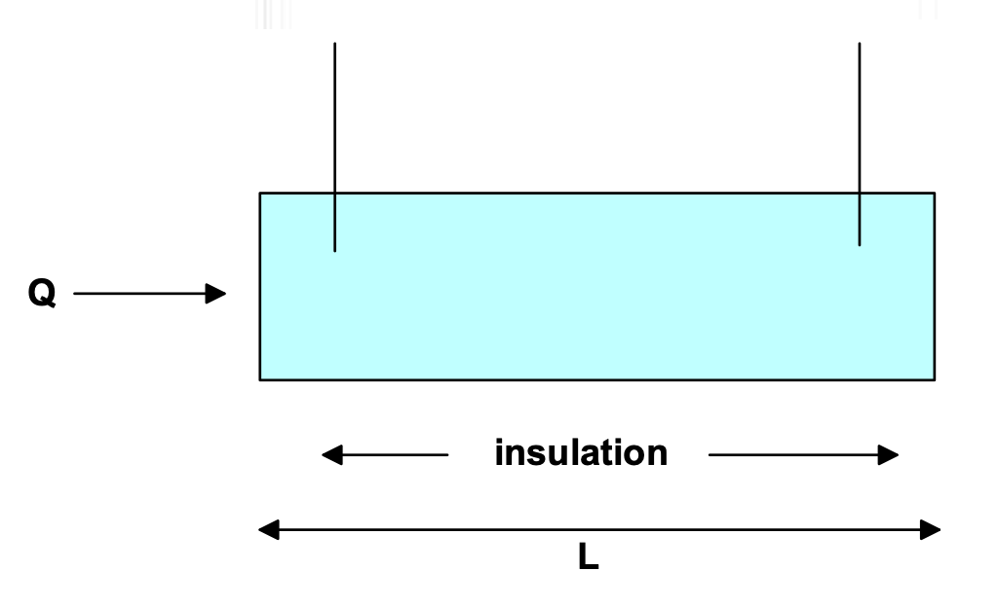

When heat flows along a good conductor (eg a metal), the heat flow Q in time t is related to the length L, of the metal bar, the temperature difference (F2 -F1) between the ends and its cross sectional area A by the equation:

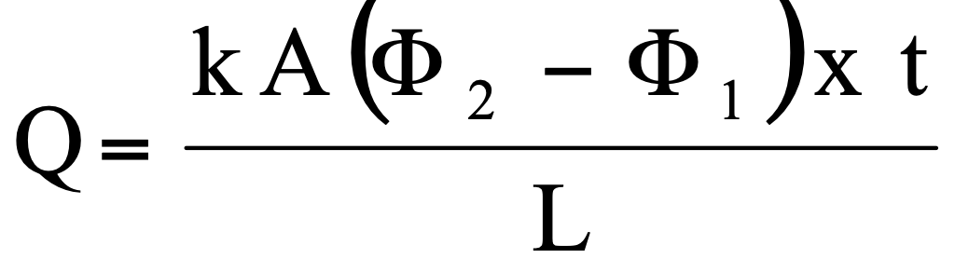

k is a constant that varies from metal to metal and is known as the coefficient of thermal conductivity. In an experiment we assume no heat is lost from the sides of the metal bar and this is achieved by extensive insulation.

In an investigation to determine the thermal conductivity of a metal, the following results were obtained. The bar had length of 0.75 m and a cross sectional area of 0.65 m2.

(a) Fill in the right hand column with the values for F2 -F1 (2 marks)

|  |  |  |  |
| --- | --- | --- | --- |
| Heat in over 2 min period  (J x 10 5) | Temperature  F2  (oC) | Temperature  F1 (oC) | F2 -F1 |
| 7.6 | 80 | 55 |  |
| 3.8 | 70 | 57 |  |
| 2.2 | 55 | 49 |  |
| 2.9 | 40 | 31 |  |
| 4.5 | 35 | 20 |  |

(b) Plot a graph of Heat in (y axis) against Temperature difference (F2 -F1) (x axis).

(3 marks)

(c) Use the graph to calculate a value for k, the thermal conductivity for this metal.

 (5 marks)

**Question 2**

**Firewalking (20 marks)**

Read the following article on FIREWALKING and answer the questions using the knowledge and experience you have encounted while studying physics.

Heat gained / lost = Mass x Specific heat x Temperature change

For a phase change Heat = mass x Latent Heat

**Para 1**

There has recently been a return to the craze of "firewalking". People are willing to pay large sums of money to be taught the secret of safely walking over red-hot coals. They are encouraged to undertake a period of spiritual purification beforehand. They are given an uplifting address by a charismatic teacher, then taken to see the fire lit. The claim that is over a "thousand degrees" seems fair. The fire seems very hot, much hotter than it really is for a very interesting reason. We are used to a heat source being a point source and as such the inverse square law applies. If we double the distance we are from the heat source then intensity is reduced by a factor of 4. We conclude when we measured the heat a distance from the heat source that the heat at the actual site will be much greater. In fact the firewalkers’ bed of flames is not a point source at all and the inverse square law does not apply. Thus the observer gets a false impression of the temperature of the coals.

**Para 2**

The fire is left to get to an uniform temperature and the audience is given another uplifting talk, stressing the need for purity, determination and giving school, especially Physics, your very best. Then outside, off with the shoes and everyone follows the leader across the coals. The secret is to be quick, usually not more than a couple of seconds at the most. Much attention is given to the preparation of the fire. The red-hot embers are like fluffy bits of charcoal. They are certainly hot but contain very little heat energy since they are so light. Thus when the bare foot touches the coal very little heat energy is transferred. After a person has skipped across, black marks are clearly visible on the coals where the feet have been. In a moment the marks vanish as the embers warm up when heat flows from the interior of the fire. Many people get small blisters but do not

notice them since they are in a temporary trance. One unfortunate physics student stood on the coals for ten seconds and had to be rushed to Joondalup Hospital with third degree burns.

**Para 3**

There is then no secret to firewalking. It is a straightforward demonstration of the basic ideas involved in Year 11 Physics. In a similar way you know that when you take a meat pie out of the oven and eat it straight away, you burn your tongue not on the pastry but the filling. When the pastry touches your tongue heat energy is transferred from the hot pastry to your relatively cold (37o C) tongue. The filling has much more heat energy than the pastry since it contains more fat/water which has a high specific heat.

**Para 4**

In the Middle Ages soldiers used to defend their castles by pouring oil at 300 o C onto the attackers. This proved a very effective defence mechanism even though the specific heat of oil is approximately half that of water.

Questions

Q1. If the source was a point source like a pot belly stove or Bunsen burner by what factor would the intensity be reduced when you are three (3) times as far away? (Para 1)

(1mark)

Q2. You stupidly put your hand in an oven at 350 oC and quickly removed it. Give two (2) Physics reasons why you would **not** get burnt. (Para 2) (2 marks)

Q3. Now you hold on to a metal tray in the same oven, why now is the sensation different?

(2 marks)

Q4. What evidence is there that heat energy has been transferred in firewalking? (Para 2)

(2 marks)

Q5. What property have the red coals got that makes firewalking "safe"? Why does this property have this effect? (Para 2) (3 marks)

Q6. Why does a skilful firewalker move quickly? (Para 2) (1 mark)

Q7. You say to the firewalker “I see that you can walk on hot coals that are 1000o C

for 5 seconds; would you please stand for 5 seconds on this electric hotplate”

Suggest what the firewalkers considered response to this might be. (3 marks)

Q8. Why is it when you eat a meat pie that has been in the oven the filling burns more than the crust. Are they both at the same temperature? (Para 3) (3 marks)

Q9. In the Middle ages defenders of castles used to pour boiling oil on to attackers. Explain why they used oil rather than water. Use the information in Para 4. A DRAFT calculation is required. (3 marks)

**END OF EXAM**